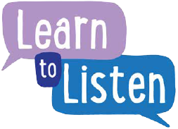
The Listening Cycle
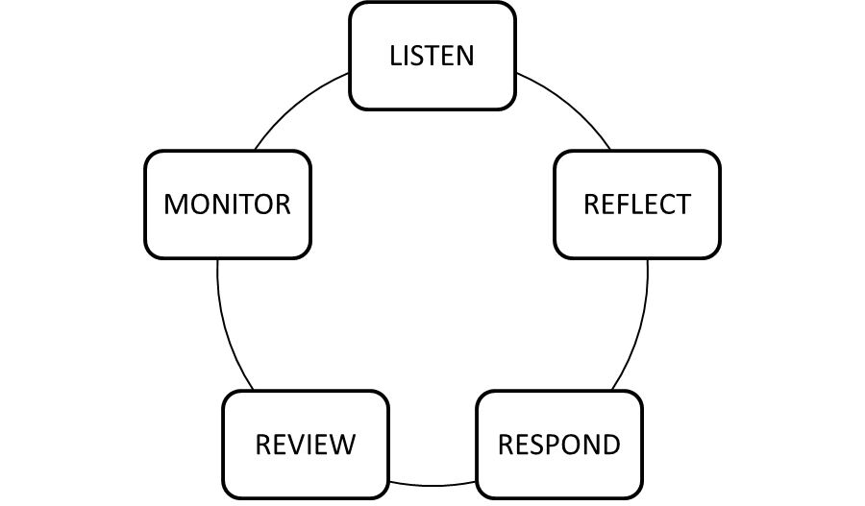
Listen
Ask the right questions using age relevant methods and resources. Prepare to be fully open to the responses.
Reflect
After listening, reflect on what has been said and how you might respond. What have you learned? How might that feed in to what you (or the church) need to do? Who can help things change?
Respond
Consider what is relevant, achievable and can be put into action. Feed back to the young people what will happen as a result of the process and how they can be involved.
Review
What happened as a result of the process? What might have been done differently? What lessons for the future have been learned?
Monitor
Look at the targets and dates that were set or agreed. Have they been achieved? What needs to happen to move them on? What difference has the agreed action made?

